***Working of this Smart Irrigation System using IoT:***

In this project NodeMCU ESP8266 has been preferred over Arduino due to its easy wifi connectivity capabilities. This is because NodeMCU has has ESP-8266(Wifi Module) chips on it which help to connect the entire system to Wifi directly.

Now, since different crops have different moisture requirements, here we consider a sample crop which will require a soil moisture of about 50-55%. Thus we program our NODEMCU accordingly.

The working of our project can be divided into the following steps:

1> As the system is powered, the soil moisture sensor module will sense the instantaneous moisture of the soil.

2> When the soil loses its moisture to less than 50%, then NodeMCU will cause the Motor pump to turn on automatically to sprinkle the water and it will continue to sprinkle the water until the moisture goes upto 55%. After that the motor pump will automatically be turned off. Thus the moisture level of the crop is being taken care of automatically.

3> The DHT11 sensor additionally records the temperature and humidity of the atmosphere continuously.

4> These sensor datas of temperature, moisture and humidity will be sent to the ThinkSpeak server at defined intervals of time, so that the conditions can be monitored from anywhere.

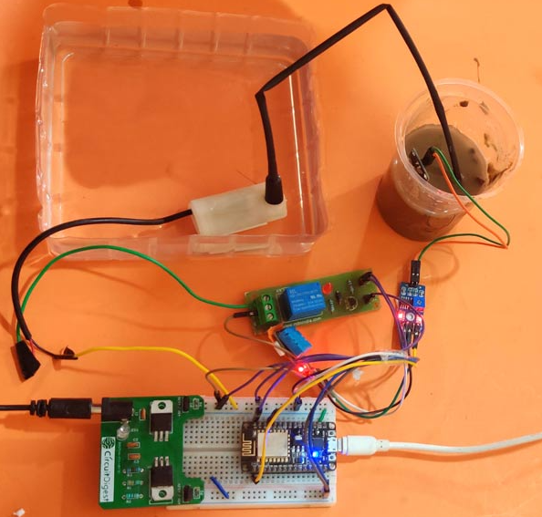

Here, for programming the ESP8266 NodeMCU module, only the DHT11 sensor library is used as external library. The moisture sensor gives analog output which can be read through the ESP8266 NodeMCU analog pin A0. Since the NodeMCU cannot give output voltage greater than 3.3V from its GPIO so we are using a relay module to drive the 5V motor pump. Also the Moisture sensor and DHT11 sensor is powered from external 5V power supply.